QUESTION : 1
Create a table called Orders with columns: order_id, user_name, total_amount, and order_date. Insert 5 sample rows with different users and order amounts, including at least one NULL value for total_amount :
CREATE TABLE Orders(
order_id INT,
user_name VARCHAR(50),
total_amount DECIMAL(10,2),
order_date DATE,
PRIMARY KEY(order_id)
);

- INSERT INTO Orders(order_id,user_name,total_amount,order_date)
VALUES
(1,'Vivek',2500.00,'2026-07-01'),
(2,'Rahul',1800.50,'2026-07-02'),
(3,'Vivek',NULL,'2026-07-03'),
(4,'Tripathi',3200.75,'2026-07-04'),
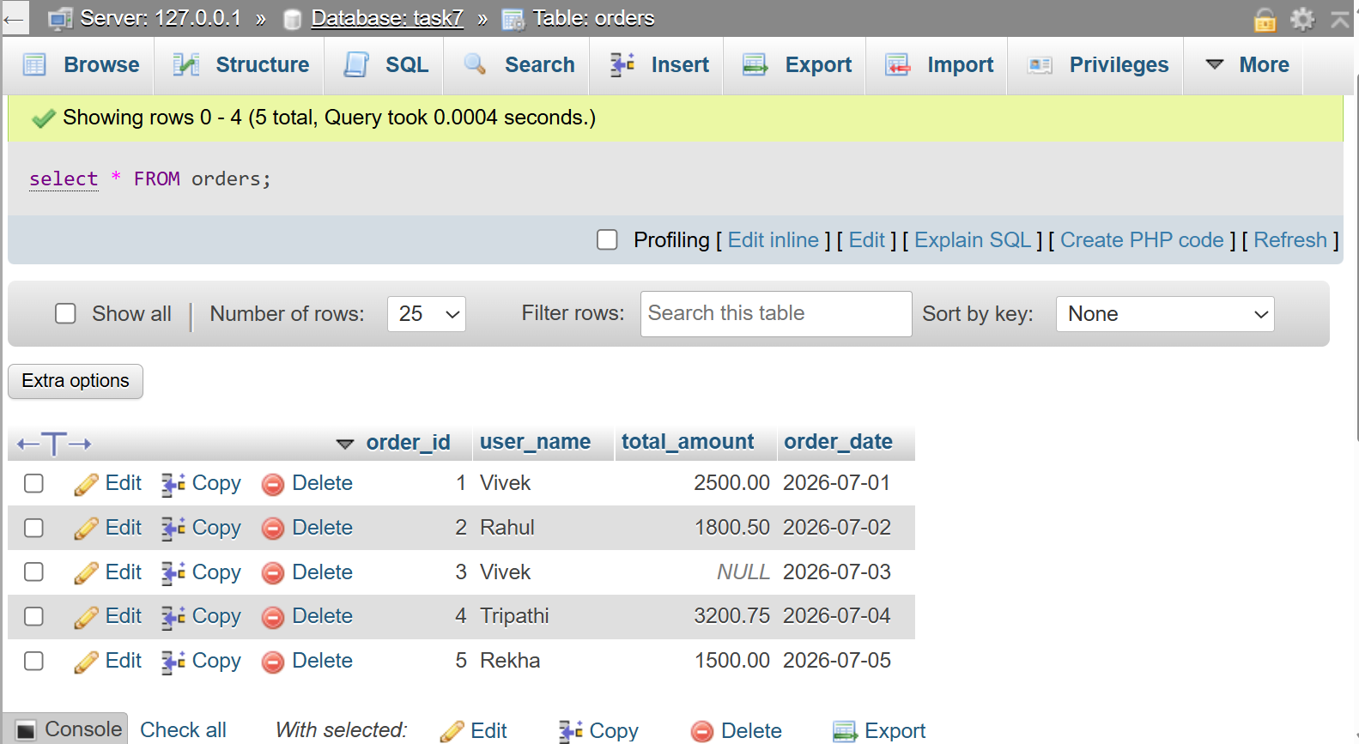
(5,'Rekha',1500.00,'2026-07-05');
QUESTION : 2
Write a SQL query to count how many orders were placed by each user in the Orders table, displaying user_name and the number of orders as order_count :

SELECT user_name,COUNT(*) AS order_count FROM Orders
GROUP BY user_name;
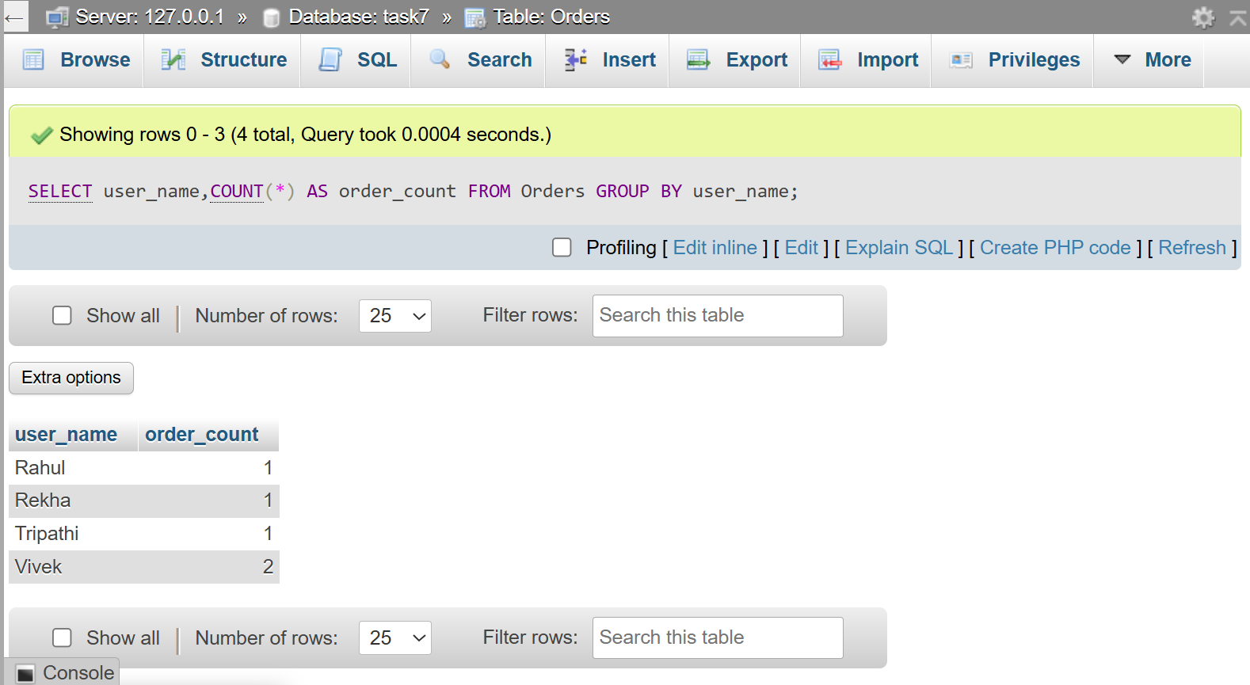

QUESTION : 3
Write a SQL query to calculate the average total_amount of all orders in the Orders table, making sure to ignore any NULL values.

- SELECT AVG(total_amount) AS average_order_amount FROM Orders;
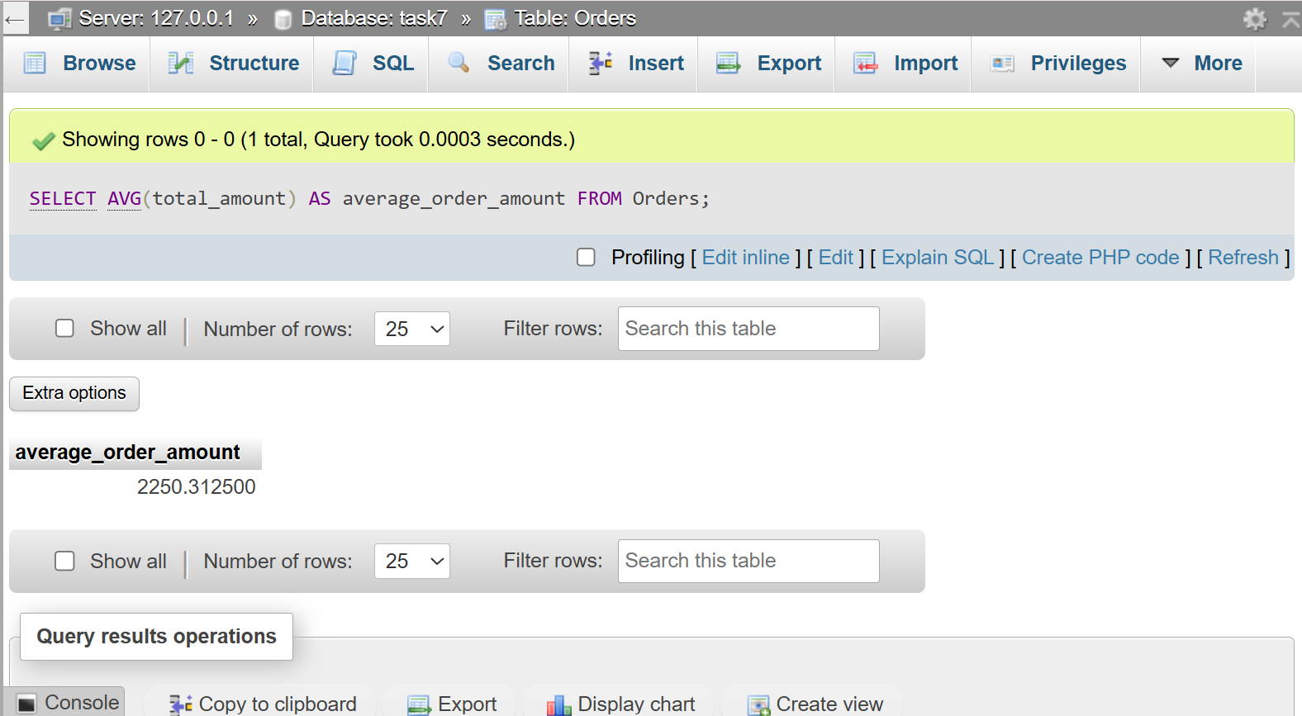

QUESTION : 4
Suppose you are building a Flipkart-style dashboard: Write a SQL query to find the highest and lowest order amounts (MAX and MIN) from the Orders table, and display both values in a single result row :
SELECT
MAX(total_amount) AS highest_order,
MIN(total_amount) AS lowest_order
FROM Orders;
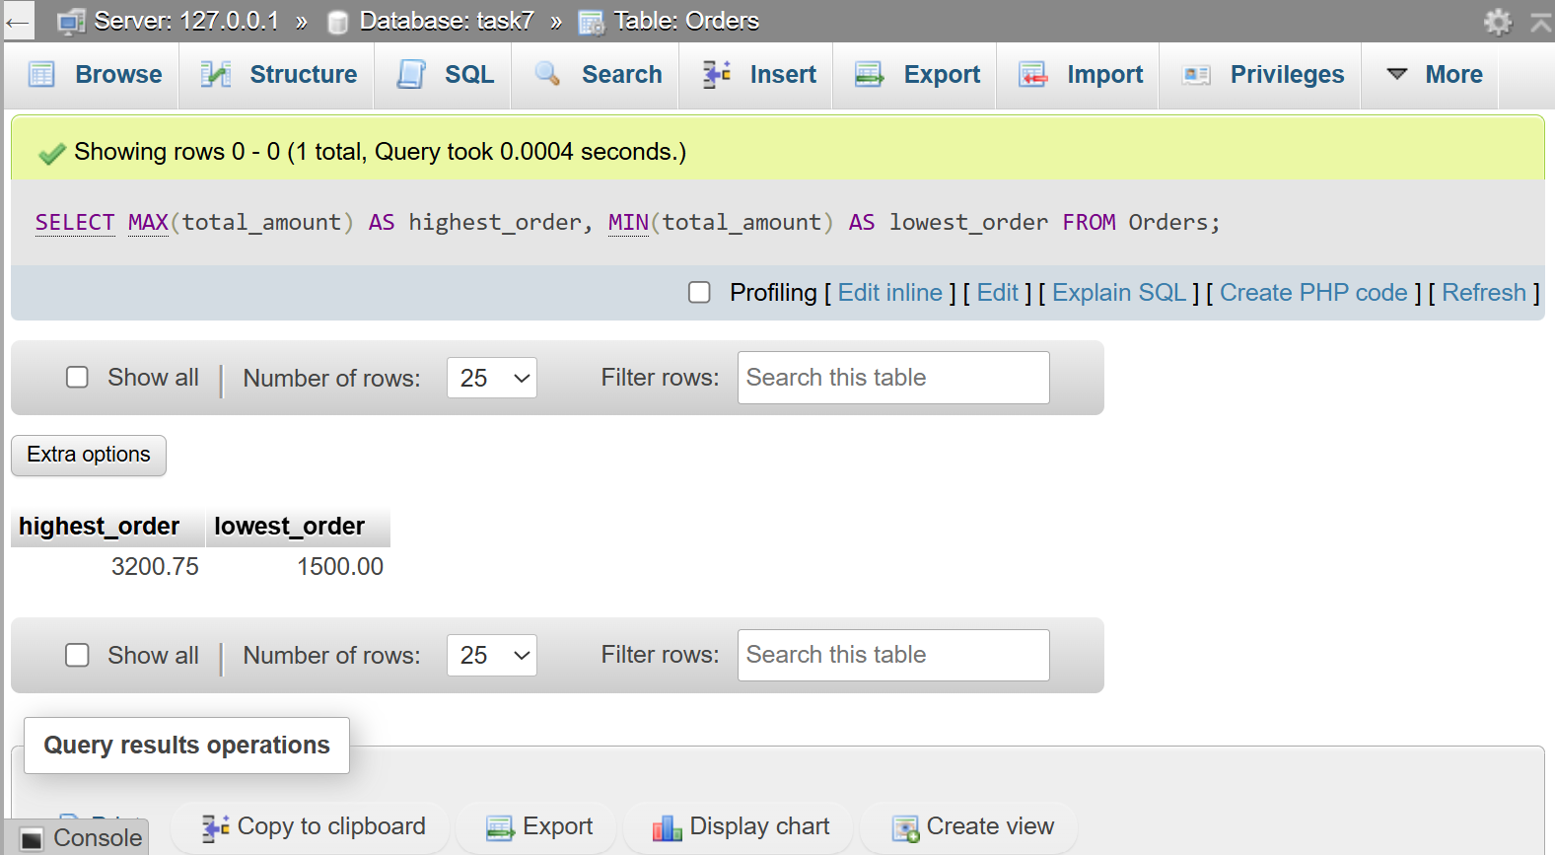

QUESTION : 5
Write a SQL query to calculate the total sales (SUM of total_amount) for all orders, but only include orders where total_amount is not NULL.<br><br><em><strong>Hint:</strong> Use a WHERE clause to filter out NULL values before applying the SUM function.</em> :

SELECT SUM(total_amount) AS total_sales FROM Orders
WHERE total_amount IS NOT NULL;

